TASK 2 – Commenting and Debugging KU3.3 - Describe the importance of adding comments to the code KU4.1 - Describe how to debug an application

a) Comment the programs that you completed in Task 1.

* Refer comments done in the project.

b) When commenting your code it is very helpful because you understand the code better when you go through it and also for other users it will have a better understanding of what is happening if they won’t have coding knowledge.

c) “NetBeans IDE provides a rich environment for troubleshooting and optimizing your applications. Built-in debugging support allows you to step through your code incrementally and monitor aspects of the running application, such as values of variables, the current sequence of method calls, etc…” (NetBeans User’s Guide)

i) Mention and explain 2 disadvantages of using System.out.println statements to debug your code.

When using System.out.println, it is really time consuming to see what exactly is error and it is not accurate to use as debugging.

ii) Explain how you can do the following debugging activities in NetBeans. For each, provide at least 1 screenshot of how you applied it to debug the program you completed in Task 1.

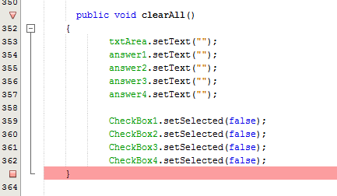

In line 351 a breakpoint is used so that when debugger goes through that line is stops and runs the program line by line till line 362.

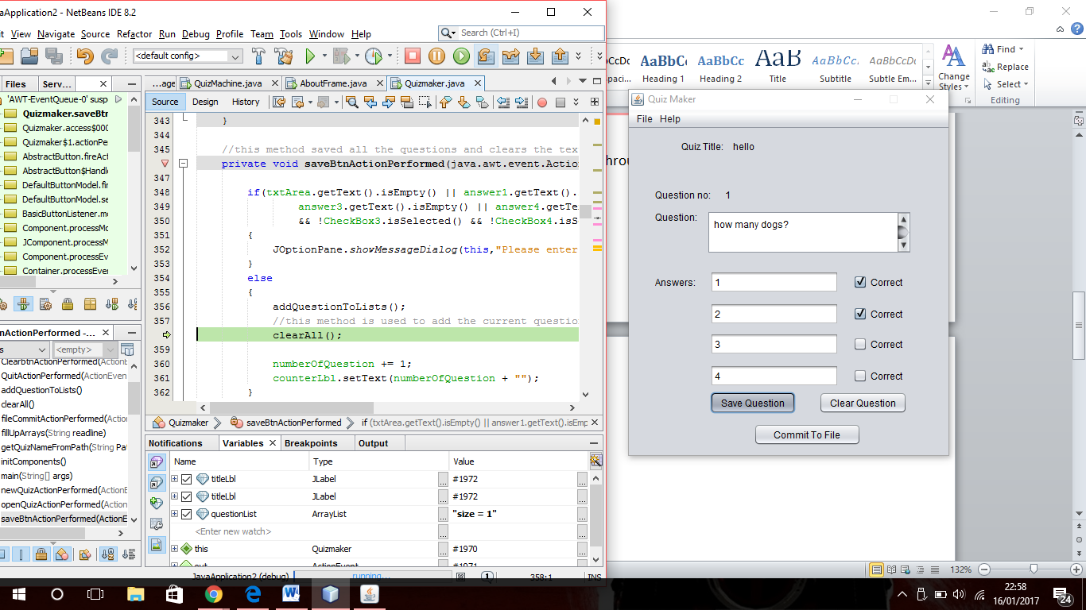

When debugging and using a breakpoint you can press the icon shown by the arrow to execute line by line and monitor each variable one by one and see their data in them.



When debugging you can write any variable that you would like to watch and monitor if its working properly and valid data is being saved.

TASK 3 – Exception Handling AA4.1 - Demonstrate the basic concepts of what exceptions are

a) Consider the Quiz Maker program created in Task 2. Assume that the following sequence of actions happen, and then answer the questions below.

Step 1 - The user runs the Quiz Maker

Step 2 – The user clicks File…New Quiz

Step 3 - The Open File Dialog opens, but the user clicks Cancel

Step 4 - The user-defined method showSaveDialog returns an empty String

Step 5 - The method getQuizNameFromPath finds the index of the . (dot) character in the file path

Step 6 - The method getQuizNameFromPath gets a substring starting from the index of the . (dot) character, until the last character of the file path

1. Which step would cause an exception to be thrown?  
   Step 3 would cause an exception.
2. What is the name of the exception that is thrown?  
   StringIndexOutOfBoundsException is the exception thrown if the user presses cancel.
3. Is this type of exception checked or unchecked, and how do you know?   
   This exception is unchecked because the code is hard to understand what the error in the program is and shows a lot of lines.
4. How can the problem be solved?

To solve this problem, a try and catch statement is used in the try put the code to be handle and if an error occurs it goes to do catch and prints a more friendly message to the user to show what is the wrong with the program.

b) Once again consider the Quiz Maker program created in Task 2. Look at the code below, and assume that the questions is an ArrayList of size 2.

for (int i = 0; 1 < questions.size(); i++) //line 1

{

System.out.println(questions.get(i)); //line 2

}

1. Which line would cause an exception to be thrown?

Lines 1 will throw an exception

1. What is the name of the exception that is thrown?

The exception thrown is Arrayoutofbounds exception